Module Seven Assignment: Dashboard Creation
This assignment builds a dashboard for the Nutrient Description (NutDes) data originally storyboarded as part of a nutrient lookup application in Module Four. The dashboard was implemented in a Jupyter Notebook against the maxiyum Neo4j graph database, using Python, the Neo4j driver, and Dash with Plotly for the interactive visualization layer.

Connecting to the Database
The notebook connects to maxiyum using the same configuration-driven approach established in earlier coursework: connection parameters are stored in database.conf and read through a config() function built on Python's ConfigParser, and a dbConnect() function builds a Bolt connection string, authenticates, and calls verify_connectivity() before the connection is used. Reusing this pattern kept credentials out of the notebook's source code and confirmed the connection was live before any queries were issued against it.
def dbConnect(filename, section):
confData = config(filename, section)
URI = "neo4j://" + confData["host"] + "/" + confData["database"]
AUTH = (confData["user"], confData["password"])
conn = GraphDatabase.driver(URI, auth=AUTH)
conn.verify_connectivity()
return conn
Before the dashboard could be built, the Nutrient Description dataset used in earlier Neo4j coursework was loaded into maxiyum from its original CSV file. A loadNutDes() function reads each row of the file and issues a MERGE statement keyed on Nutrient Code, so the load can be re-run safely without creating duplicate nodes. Including this step directly in the notebook kept the data load, the queries, and the dashboard itself in a single reproducible pipeline rather than relying on a manual import step outside the notebook.

Storyboard Iteration
The original Module Four storyboard was designed around the calval PostgreSQL database and modeled a nutrient lookup application: a user would search for a food item and the application would return that food's associated nutrient values from related relational tables. Building the dashboard against maxiyum instead of calval required revisiting that storyboard rather than implementing it as originally designed.
The most significant adjustment was scope. The original storyboard assumed a food-to-nutrient relationship: a screen where selecting a food item revealed a list of its nutrient values. The maxiyum graph currently models only the nutrient catalog itself, as a set of NutDes nodes carrying a code, description, abbreviation, and unit of measure; it does not yet contain Food nodes or the relationships that would connect a food item to its nutrient values. Rather than building a dashboard around a relationship that does not exist in the current data, the storyboard was adjusted to a nutrient-catalog browser: a user searches or filters the existing nutrient list and sees how those nutrients are distributed across units of measure, instead of searching by food and retrieving nutrient values for that food.
This adjustment was necessary rather than optional. A storyboard's screens are only as good as the data behind them, and presenting search-by-food as a feature when no Food nodes exist would have produced a dashboard that looked complete but could not actually be exercised against real data. Scoping the storyboard down to what the graph currently supports kept the dashboard honest about its data source while still demonstrating the same underlying interaction pattern from the original design: a search or filter control narrowing a displayed result set. The food-to-nutrient relationship the original storyboard envisioned remains a reasonable direction for the dashboard's data model to grow into, and is discussed further in the usability enhancement section below.

Dashboard Queries
Three Cypher queries populate the dashboard, each wrapped in its own Python function and executed through the Neo4j driver's execute_query() method.
# All nutrients (feeds the data table)
MATCH (n:NutDes)
RETURN n.NutrientCode AS code, n.NutrientDescription AS description,
n.NutrientDescriptionAbbrev AS abbrev, n.NutrientUnit AS unit
ORDER BY n.NutrientCode

# Nutrient count by unit (feeds the bar chart)
MATCH (n:NutDes)
RETURN n.NutrientUnit AS unit, count(n) AS total
ORDER BY total DESC

# Total nutrient count (feeds the summary statistic)
MATCH (n:NutDes) RETURN count(n) AS total
Each query was executed once in the notebook to confirm it returned the expected results before being wired into the dashboard. The first query returned all twenty NutDes nodes currently present in maxiyum as a pandas DataFrame; the second returned four rows, one for each unit of measure represented in the data (grams, milligrams, micrograms, and kilocalories); and the third returned a single integer used in the dashboard's header text.

Building the Interactive Dashboard
The dashboard itself was built with Dash and Plotly Express, rendered inline inside the Jupyter Notebook output cell. The rubric's suggested JupyterDash module is deprecated as of recent Dash releases; Dash now provides the same inline-Jupyter rendering directly, so the dashboard uses the current Dash class with app.run(jupyter_mode='inline') rather than the older JupyterDash wrapper.
app = Dash(__name__)
app.layout = html.Div([
html.H2('Maxiyum Nutrient Dashboard'),
html.P(f'Total nutrients tracked: {total_nutrients}'),
dcc.Input(id='search-box', type='text',
placeholder='e.g. Calcium or 301'),
dash_table.DataTable(id='nutrient-table',
data=df_all.to_dict('records'), page_size=10),
dcc.Graph(id='unit-bar-chart', figure=bar_fig),
])

@app.callback(
Output('nutrient-table', 'data'),
Output('unit-bar-chart', 'figure'),
Input('search-box', 'value')
)
def filterDashboard(search_value):
# filters df_all by description or code, then rebuilds
# both the table data and the unit bar chart from the
# filtered subset before returning them together
...
Figure 1 shows the dashboard running inline in Jupyter with no search filter applied, displaying all twenty nutrients currently loaded in maxiyum and their distribution across the four units of measure present in the data.
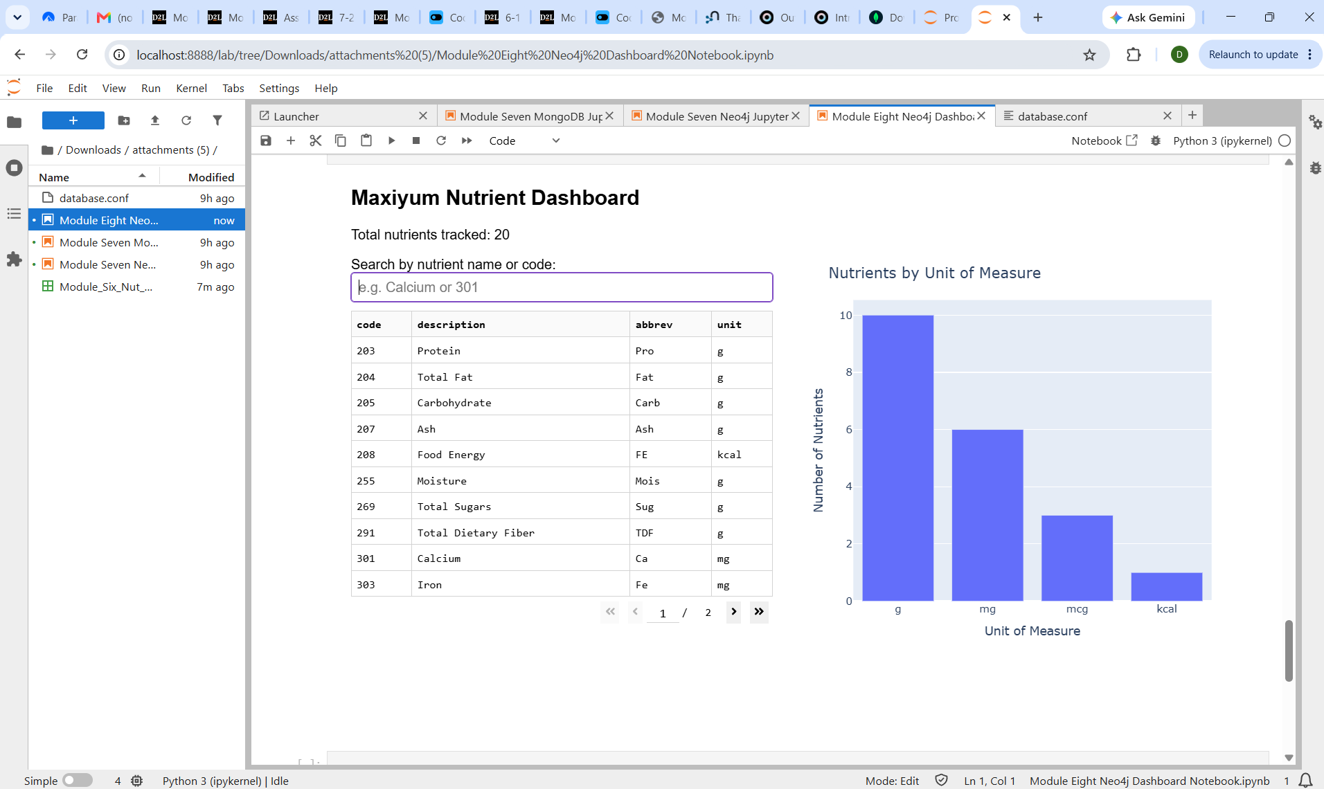
Figure 1. The Maxiyum Nutrient Dashboard running inline in Jupyter Notebook, showing the full nutrient table and the bar chart of nutrients by unit of measure.

Dashboard Description and Design Decisions

Information Included
The dashboard presents three pieces of information drawn directly from maxiyum: a running count of total nutrients tracked, a searchable table listing every nutrient's code, description, abbreviation, and unit of measure, and a bar chart summarizing how many nutrients fall under each unit of measure. The count in Figure 1 reads twenty rather than the nineteen nutrients in the original Module Six data file because a Zinc test record (Nutrient Code 777) created in earlier coursework while developing the Module Seven CRUD notebook is still present in maxiyum alongside the newly loaded set; it was left in place deliberately to show the dashboard reflecting the database's actual current state rather than a curated subset of it.

Interactive Capabilities
The dashboard's primary interactive element is a text search box that filters by nutrient description or nutrient code. Typing a value such as a partial nutrient name or a numeric code narrow both the data table and the bar chart to only the matching nutrients, so the chart's unit breakdown always reflects whatever subset of the data is currently selected rather than remaining a static, disconnected reference view. This was a deliberate design choice: an earlier version of the dashboard updated only the table on search, leaving the chart fixed on the full dataset, but tying both outputs to the same search input gives a more coherent view of how a filtered result set relates to the dataset as a whole. The data table additionally supports its own built-in pagination, displaying ten rows per page so the full nutrient list remains easy to scan without becoming a single, overwhelming block of text.

Usability and Functionality Enhancement
The most valuable enhancement to this dashboard would be restoring the food-to-nutrient relationship described in the original Module Four storyboard, rather than limiting the dashboard to the nutrient catalog alone. A user exploring nutrient data is typically more interested in a specific food's nutrient profile than in the catalog of nutrient definitions by itself, and the current dashboard cannot answer that question because the underlying graph has no Food nodes or relationships connecting them to NutDes nodes.
Implementing this change would require three things. First, a Food node type would need to be added to the maxiyum schema, along with a relationship type, such as HAS_NUTRIENT, connecting each Food node to the NutDes nodes relevant to it, carrying the measured amount as a relationship property. Second, the source nutrient values data, the food-level counterpart to the Nutrient Description data already loaded, would need to be loaded into the graph using the same MERGE-based loading pattern already established in this notebook, extended to also create the relevant relationships. Third, the dashboard's layout and callback would need a new food-selection control, such as a dropdown or a second search box, along with a query such as MATCH (f:Food)-[r:HAS_NUTRIENT]->(n:NutDes) WHERE f.FoodName = $food RETURN n.NutrientDescription, r.Amount, n.NutrientUnit, and a second chart or table bound to that query's output. None of these three pieces depends on the others being finished first, which would let the enhancement be implemented and tested incrementally rather than as a single large change.

